Project Planning Phase
AI FitTrack – Modern Project Planning Template
Date | 24 September 2026
Team ID | SWTID-2026-9501
Project Name | AI FitTrack – AI-Powered Fitness Tracking System
Maximum Marks | 5 Marks
Product Backlog, Sprint Schedule, Estimation, Velocity & Burndown
Use the below template to plan AI FitTrack releases, sprints, stories, story points and delivery evidence.
Sprint | Functional Requirement (Epic) | User Story Number | User Story / Task | Story Points | Priority | Team Members
Sprint-1 | Authentication & Profile | US-01 | As a user, I can register and log in securely using email and password. | 5 | High
Sprint-1 | Authentication & Profile | US-02 | As an authenticated user, I can view and update my fitness profile. | 3 | High
Sprint-2 | Workout Tracking | US-03 | As a user, I can add a workout with name, category, duration, calories and date. | 5 | High
Sprint-2 | Workout Tracking | US-04 | As a user, I can view, update and delete my own workouts. | 5 | High
Sprint-3 | Search & Analytics | US-05 | As a user, I can search, paginate and filter workouts by category and date. | 3 | Medium
Sprint-3 | Dashboard | US-06 | As a user, I can view totals, averages, streak, weekly activity and recent workouts. | 5 | High
Sprint-4 | AI Fitness | US-07 | As a user, I can request a personalized AI workout recommendation. | 5 | High
Sprint-4 | AI Fitness | US-08 | As a user, I can request AI-generated fitness insights from my activity metrics. | 5 | Medium
Sprint-4 | Frontend & QA | US-09 | As a user, I can use the React interface and receive clear validation/error messages. | 5 | High
Project Tracker, Velocity & Burndown Chart: (4 Marks)
Sprint | Total Story Points | Duration | Sprint Start Date | Sprint End Date (Planned) | Story Points Completed (as on Planned End Date) | Sprint Release Date (Actual)
Sprint-1 | 13 | 6 Days | 24 Sep 2026 | 29 Sep 2026 | Planned
Sprint-2 | 13 | 6 Days | 30 Sep 2026 | 05 Oct 2026 | Planned
Sprint-3 | 13 | 6 Days | 06 Oct 2026 | 11 Oct 2026 | Planned
Sprint-4 | 15 | 6 Days | 12 Oct 2026 | 17 Oct 2026 | Planned
Burndown Chart:
A burn down chart is a graphical representation of work left to do versus time. It is often used in agile software development methodologies such as Scrum. However, burn down charts can be applied to any project containing measurable progress over time.
AI FitTrack Release Plan
Release 1 establishes secure identity and profile management. Release 2 adds the workout lifecycle. Release 3 adds search, filters and dashboard analytics. Release 4 integrates the React experience, AI services and final acceptance testing.
• Definition of Done: code reviewed, API tested in Thunder Client, database verified in MongoDB Atlas, error paths checked, and screenshot evidence captured.
• AI Definition of Done: valid Gemini project access, model configured, recommendation and insight endpoints return controlled JSON responses.
• Security Definition of Done: JWT required for protected routes, password hashing enabled, secrets kept in .env and excluded from source control.
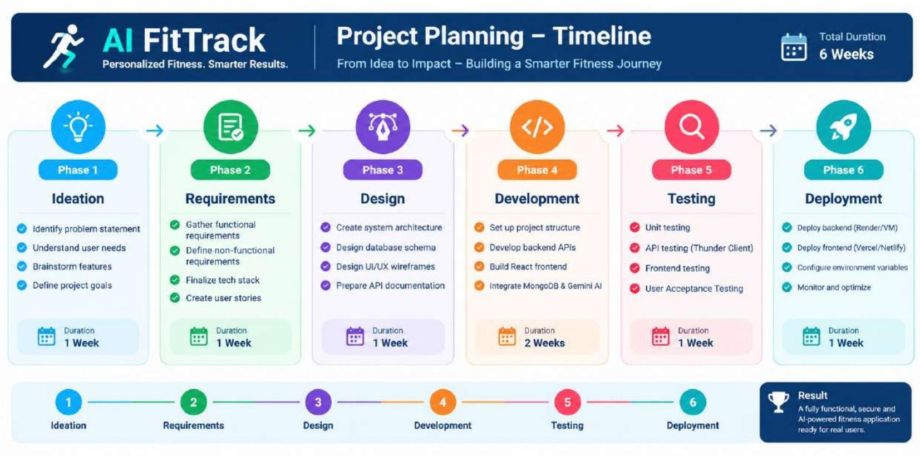
Velocity & Burndown Evidence
For each sprint, record planned story points, completed story points and remaining work at the end of each working day. The same tracking method should be used across all releases so velocity and delivery trends remain comparable.
